**Python Libraries**

**for**

**Recommendation Systems**

A recommendation system is a data science problem that predicts what users want based on historical data. It can be considered as a system to filter information to predict the best “rating” a user would give to an item.

Many open-source recommender system libraries are available to help you get started with your first implementation of the recommendation model. Here are

* Recmetrics
* Surprise
* DeepCTR
* OpenRec
* fastFM
* LightFM

# **Recmetrics:**

Recmetrics is a Python library that helps analyze and measure how well recommendation systems perform. It provides tools to check the accuracy, relevance, and user satisfaction of recommendations, making it easier for developers to evaluate their models.

**Key Features of Recmetrics**

1. **Evaluation Metrics**: Recmetrics includes various metrics to assess different aspects of recommendation systems:
   * **Accuracy**: Metrics such as precision, recall, and F1 score to evaluate how accurately recommendations match user preferences.
   * **Coverage**: Measures how much of the available items are recommended, indicating the system's diversity.
   * **Novelty and Diversity**: Metrics that track how diverse and novel the recommendations are, crucial for user satisfaction.
   * **Serendipity**: Gauges how unexpected or pleasantly surprising recommendations are.
   * **User Satisfaction**: Metrics to assess user satisfaction with recommendations, helping to improve long-term engagement.
2. **Visualization Tools**: Recmetrics includes visualization tools to create charts and graphs for better insights. These tools can display distribution of recommendation accuracy, coverage, and other important factors.
3. **Compatibility**: The library is compatible with popular libraries like Pandas and Scikit-learn, making it easy to integrate into data analysis pipelines.

**Common Metrics in Recmetrics:**

1. **Precision**: Measures the correctness of the recommendations.
2. **Recall**: Measures how well the items are represented in the recommendations.
3. **F1 Score**: Harmonic mean of precision and recall; useful for scenarios where you need a balance between the two.
4. **Mean Average Precision (MAP)**: Measures the precision of recommendations across all relevant items.
5. **Normalized Discounted Cumulative Gain (NDCG)**: Evaluates the ranking quality by taking into account the position of relevant items
6. **Serendipity and Novelty**: Adds a subjective measure of the "pleasant surprise" factor of recommendations.

# **Surprise:**

The Surprise library, a Python toolkit for building recommendation systems, is designed for evaluating and implementing rating prediction algorithms with a focus on simplicity and flexibility.

Surprise has a range of built-in algorithms, from classic similarity-based approaches like K-Nearest Neighbors to more complex matrix factorization methods like Singular Value Decomposition (SVD) and Non-negative Matrix Factorization (NMF). It is especially useful for collaborative filtering tasks, where it excels in making predictions based on user-item interactions.

**Surprise offers several notable features for recommendation model development:**

1. **Pre-built Datasets and Custom Data Loading**: Surprise provides popular datasets, such as the MovieLens dataset, for quick testing, but also allows for custom dataset integration using Pandas DataFrames or CSV files.
2. **Model Selection and Evaluation**: Built-in cross-validation functions and metrics like RMSE (Root Mean Square Error) and MAE (Mean Absolute Error) help streamline the evaluation process, while grid and randomized search tools support hyperparameter tuning.
3. **API Consistency with Scikit-Learn**: Surprise’s API is designed to be similar to Scikit-Learn, making it accessible for those familiar with the Python ML ecosystem.
4. **Custom Algorithm Development**: Users can create new recommendation algorithms with minimal code, which makes it a powerful tool for researchers and developers exploring unique recommendation strategies

Metrics used in Surprise:

1. **Root Mean Square Error (RMSE)**: RMSE is one of the most commonly used metrics to evaluate the accuracy of prediction models in Surprise. It measures the average magnitude of prediction errors by penalizing larger errors more heavily than smaller ones. RMSE is calculated as: 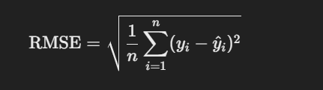

where yiy_iyi​ is the actual rating and y^i\hat{y}_iy^​i​ is the predicted rating.

1. **Mean Absolute Error (MAE)**: Unlike RMSE, MAE gives equal weight to all errors, measuring the average absolute difference between actual and predicted ratings: 

This metric is useful for understanding the general accuracy of predictions.

1. **Precision@K and Recall@K**: These metrics assess recommendation performance by checking if relevant items are present in the top-K recommendations for each user:

* **Precision@K**: Measures the proportion of relevant items in the top-K recommendations.
* **Recall@K**: Calculates the proportion of all relevant items that appear in the top-K list.

1. **Coverage**: Measures the percentage of items that can be recommended, indicating how diverse the recommendation model is. Higher coverage is typically better as it shows the model can recommend a broader range of items.
2. **Hit Rate**: This metric is used to see how often the top-K recommendations include at least one item that the user interacted with. This is especially helpful in top-N recommendation tasks.
3. **Novelty and Diversity**: While not explicitly implemented in Surprise, these metrics are often calculated in recommendation systems to assess the uniqueness and variety of recommendations, which impact user satisfaction.

# **DeepCTR:**

DeepCTR is a comprehensive Python library focused on deep learning models for Click-Through Rate (CTR) and other prediction tasks, commonly used in recommendation systems. It provides a set of predefined models and customizable features that enable developers to quickly test various architectures. Here is a breakdown of its main components and how to use them.

**Core Features of DeepCTR**

* **Predefined Models**: DeepCTR includes a wide range of model architectures that are popular for CTR prediction:
  + **DeepFM**: Combines the strengths of deep neural networks and factorization machines to capture both high- and low-order feature interactions.

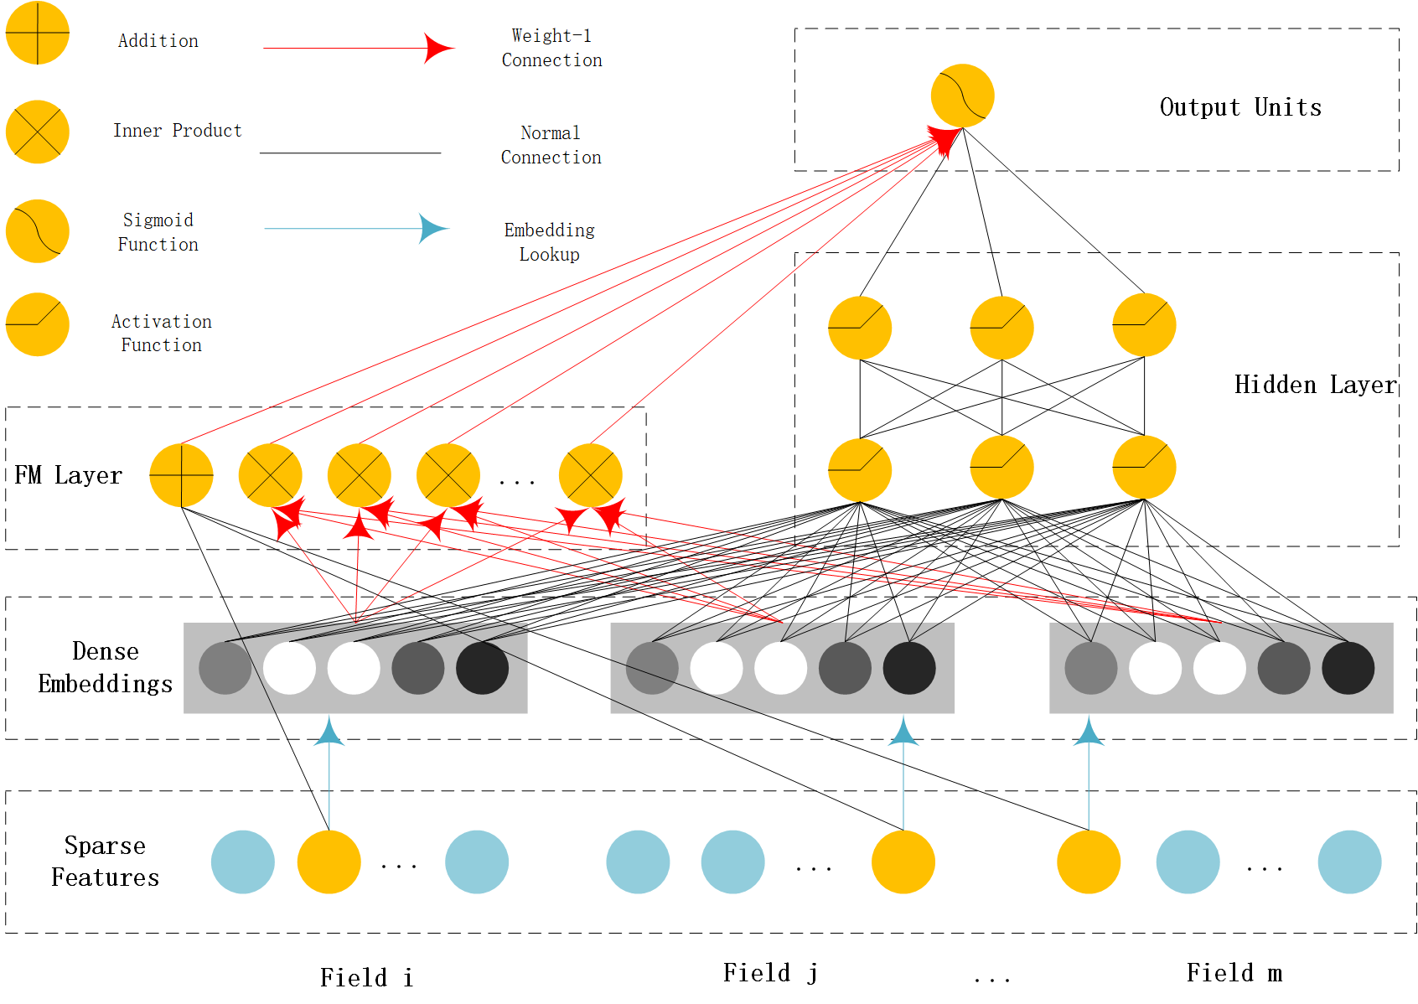

* + **Wide & Deep (WDL)**: Combines linear and deep layers for generalization and memorization in recommendation systems.

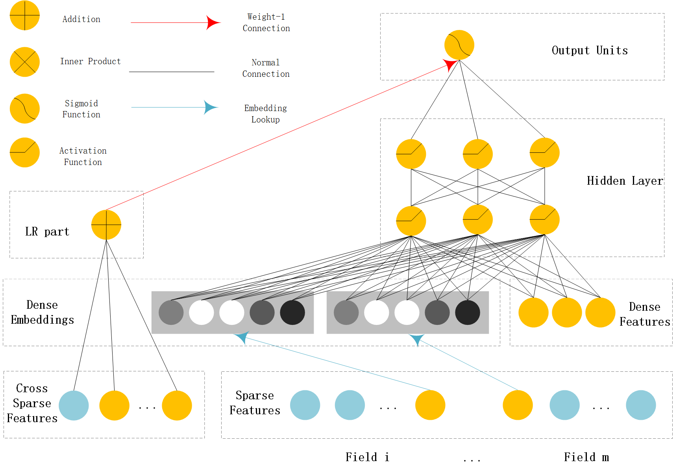

* + **NFM (Neural Factorization Machine)**: Uses a bi-interaction pooling layer to capture feature interactions.

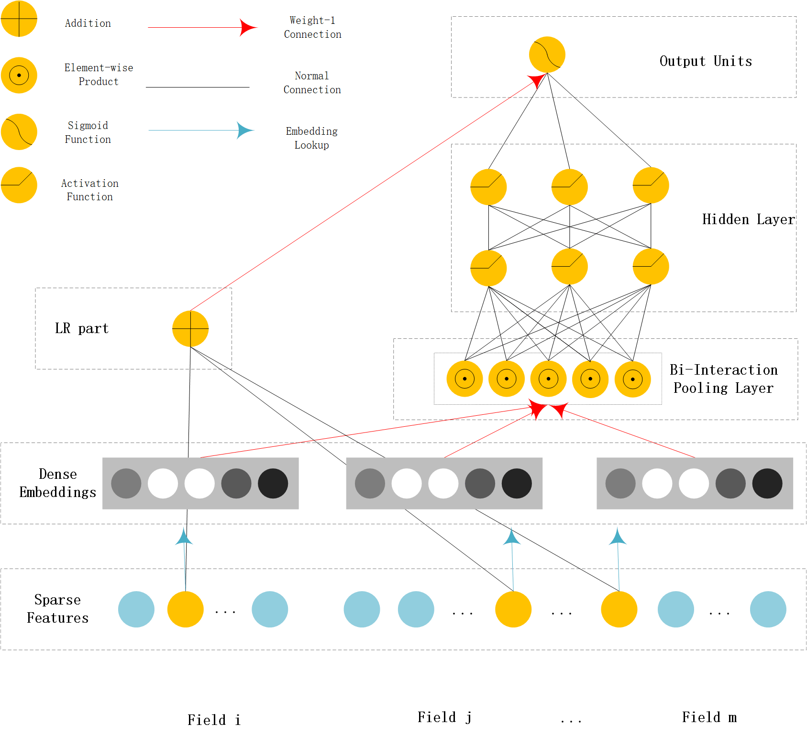

* + **xDeepFM**: Extends DeepFM with a Compressed Interaction Network for more complex feature interactions.

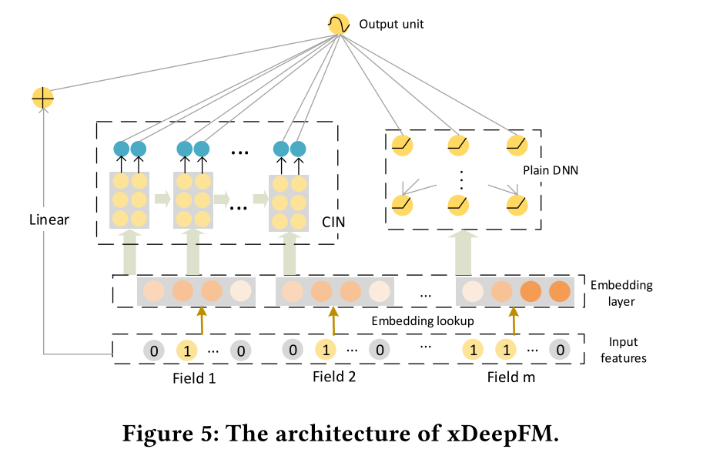

* + **DIN (Deep Interest Network)** and **DIEN (Deep Interest Evolution Network)**: Focus on modeling sequential user behavior by considering temporal interest changes.
* **Multi-Task Learning**: Supports multi-task models like MMOE (Multi-gate Mixture of Experts) and PLE (Progressive Layered Extraction), allowing the model to learn from multiple tasks, such as CTR prediction and post-click conversion rates.
* **Embedding Layers and Feature Columns**: DeepCTR includes flexible tools to define embedding layers for categorical features, as well as dense features. This customization makes it easy to adapt the model to various datasets and user-item interaction types.

**Metrics for DeepCTR:**

1. **AUC (Area Under the ROC Curve):** Measures the model’s ability to distinguish between positive and negative classes. It’s widely used in binary classification tasks because it’s threshold-independent and provides a summary of model performance across different classification thresholds.
2. **Log-Loss (Binary Cross-Entropy):** Calculates the error between the predicted probabilities and the actual binary labels. It penalizes large errors, so models with lower log-loss scores are better as they indicate that the predicted probabilities are close to the actual values.
3. **Accuracy:** Measures the percentage of correct predictions. However, accuracy may not always be the best metric in CTR tasks, especially when data is imbalanced (e.g., a low click rate).
4. **Precision, Recall, and F1 Score:** These are additional metrics that can be calculated depending on specific requirements:

* **Precision:** The ratio of correctly predicted positive observations to the total predicted positives. It’s useful when false positives are costly.
* **Recall**: The ratio of correctly predicted positive observations to all actual positives. High recall is desired when missing true positives is costly.
* **F1 Score**: A weighted average of precision and recall, used when there’s a need for a balance between the two.

1. **Mean Absolute Error (MAE) and Root Mean Square Error (RMSE):** While not as common in CTR models as in regression tasks, these metrics measure the average absolute and squared differences between predicted and actual values. They can be informative in tuning probability-based outputs.

# **OpenRec:**

OpenRec is an advanced open-source framework designed to aid in building and evaluating modular neural-network-based recommendation algorithms, particularly useful for handling collaborative filtering, sequence-aware, and context-aware recommendations. Below is a breakdown of OpenRec's documentation, key components, mathematical foundation, and metrics.

**1. Core Architecture and Components**

OpenRec’s structure is highly modular. The framework consists of reusable components such as embeddings, objective functions, and samplers, which form the building blocks of recommendation algorithms. These modules can be reconfigured or extended, allowing researchers to implement custom algorithms.

**Main Components**

* **Modules**: Represent individual functions within a recommendation system, like embeddings, neural layers, or scoring functions.
* **Models**: A collection of modules built to perform end-to-end recommendation tasks, such as matrix factorization, neural collaborative filtering, or hybrid models.
* **Samplers**: Generate data batches for training and evaluation. They provide positive and negative instances based on the chosen algorithm, which are crucial in implicit feedback recommendation systems.

**2. Mathematical Theory Behind Algorithms**

Several state-of-the-art recommendation algorithms are implemented in OpenRec, each with its own mathematical basis. Here’s a summary of some commonly used algorithms:

**a) Matrix Factorization**

Matrix Factorization (MF) is a foundational approach in recommendation systems. It decomposes the user-item interaction matrix RRR into the product of two lower-dimensional matrices, PPP (user latent factors) and QQQ (item latent factors):



The goal is to minimize the reconstruction error, often achieved via an optimization objective, such as Mean Squared Error (MSE).

**b) Bayesian Personalized Ranking (BPR)**

BPR is a pairwise learning-to-rank approach. It aims to rank observed (positive) interactions higher than unobserved (negative) ones. The objective function is:

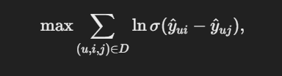

where σ\sigmaσ is the sigmoid function, y^ui\hat{y}_{ui}y^​ui​ is the predicted score for user uuu on item iii, and DDD is the training dataset consisting of triplets (u,i,j)(u, i, j)(u,i,j), where iii is a preferred item over jjj.

**c) Neural Collaborative Filtering (NCF)**

NCF extends traditional MF by applying deep learning techniques to capture complex user-item interactions. It uses neural layers to learn a non-linear function fff of user and item embeddings:

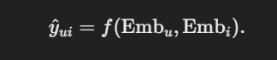

The model is trained by minimizing binary cross-entropy or other similar loss functions, making it effective for implicit feedback.

**3. Evaluation Metrics**

OpenRec uses various metrics to evaluate recommendation performance, typically focusing on the relevance and ranking quality of recommendations:

* **Hit Ratio (HR)**: Measures the proportion of correctly recommended items within a top-K recommendation list.



* **Normalized Discounted Cumulative Gain (NDCG)**: Takes the position of correct recommendations into account, giving higher scores to recommendations that appear earlier in the list.



* **AUC (Area Under the Curve)**: A ranking metric that evaluates the probability that a randomly chosen positive item ranks higher than a randomly chosen negative item.
* **Mean Reciprocal Rank (MRR)**: The average of the reciprocal ranks of the first relevant item in each user’s recommendation list.

# **fastFM:**

The FastFM library is a Python package for factorization machines (FM), a type of model that’s well-suited for recommendation systems and prediction tasks involving sparse, high-dimensional data, such as in collaborative filtering, CTR prediction, and matrix factorization. FastFM offers both mathematical rigor and computational efficiency, with a focus on fast learning algorithms.

**1. Overview of Factorization Machines (FM)**

Factorization Machines (FMs) model interactions between variables through factorized parameters, enabling them to capture complex interactions without explicitly computing all possible feature combinations. FMs generalize matrix factorization and polynomial regression, providing a flexible framework for collaborative filtering and predictive analytics on sparse data.

The general form of the FM model is:

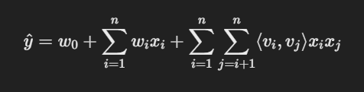​

where:

* y^\hat{y}y^​ is the predicted outcome,
* w0w_0w0​ is the global bias,
* wiw_iwi​ are the weights for individual features,
* viv_ivi​ are factor vectors that capture feature interactions,
* ⟨vi,vj⟩\langle v_i, v_j \rangle⟨vi​,vj​⟩ represents the dot product between feature embeddings viv_ivi​ and vjv_jvj​, modeling second-order interactions.

The main advantage of FMs lies in their ability to estimate interactions in a low-rank space, which makes them efficient in high-dimensional settings.

**2. FastFM’s Algorithms and Optimization Methods**

FastFM supports multiple optimization approaches to train FMs efficiently, especially with large datasets:

* **Alternating Least Squares (ALS)**: ALS is an efficient method for solving linear equations iteratively, especially useful for recommendation tasks like matrix factorization.
* **Stochastic Gradient Descent (SGD)**: SGD optimizes the objective function by iteratively updating parameters with gradient steps, which is suitable for large-scale data and online learning.
* **Markov Chain Monte Carlo (MCMC)**: FastFM uses MCMC to approximate a Bayesian posterior, providing uncertainty estimates around parameters.

These optimization methods in FastFM allow for flexibility in model training depending on the use case, with ALS offering deterministic solutions, SGD favoring scalability, and MCMC adding a probabilistic interpretation.

**3. Metrics for Evaluating Factorization Machines**

Common metrics for evaluating FMs, especially in recommendation and prediction tasks, include:

* **Root Mean Square Error (RMSE)**: Measures the average error between predicted and actual values, emphasizing large errors due to squaring.

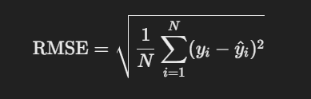

* **Mean Absolute Error (MAE)**: Calculates the average absolute differences between predictions and ground truths, providing an error measure that’s less sensitive to outliers than RMSE.



* **Log Loss (Binary Cross-Entropy)**: In binary prediction tasks, such as CTR or implicit feedback, log loss measures the accuracy of predicted probabilities against binary labels.



* **Precision@K and Recall@K**: These ranking metrics are often used in recommendation systems to assess the proportion of relevant items in the top-K recommended list.

# **LightFM:**

LightFM is a Python library tailored for building and evaluating recommendation systems that use hybrid models, specifically combining collaborative and content-based approaches. The library is particularly useful for implicit and explicit feedback, allowing for the integration of side information, like user and item features, which improves recommendations for sparse datasets. Here’s a breakdown of LightFM’s documentation, underlying mathematical theory, and metrics.

**1. Overview of LightFM**

LightFM is based on matrix factorization but extends it by incorporating side information about users and items to improve performance on cold-start and sparse data. The library offers four main loss functions—logistic, Bayesian personalized ranking (BPR), weighted approximate-rank pairwise (WARP), and k-OS WARP—allowing flexibility based on the recommendation task.

**2. Mathematical Theory Behind LightFM**

The core mathematical foundation of LightFM lies in **matrix factorization with feature embeddings**. The model learns latent representations for users and items that capture interaction patterns in the data.

The predicted interaction y^ui\hat{y}_{ui}y^​ui​ for a user uuu and item iii is computed as:



where:

* qiq_iqi​ and pup_upu​ are the latent vectors for item iii and user uuu,
* bub_ubu​ and bib_ibi​ represent biases for user uuu and item iii.

LightFM introduces additional embeddings to integrate user and item metadata features. When user and item features xux_uxu​ and xix_ixi​ are available, the prediction becomes:



where fuff_{uf}fuf​ and gigg_{ig}gig​ represent feature vectors for users and items, respectively.

**Loss Functions in LightFM**

LightFM provides four loss functions, each tailored to a different recommendation task:

1. **Logistic Loss**: Optimizes for binary classification, predicting interaction probability.



where yuiy_{ui}yui​ is the true interaction.

1. **BPR Loss (Bayesian Personalized Ranking)**: Optimizes for pairwise ranking, encouraging observed interactions to rank higher than unobserved ones.

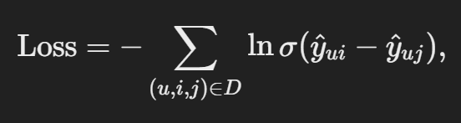

where DDD is a dataset of triplets where item iii is preferred over jjj.

1. **WARP Loss (Weighted Approximate-Rank Pairwise)**: Focuses on maximizing the top-K ranking of positive items by sampling negative items until a ranking violation is observed.
2. **k-OS WARP Loss**: A variant of WARP that considers the k-th positive interaction rather than the first one, which can help stabilize training in cases with many interactions.

**3. Evaluation Metrics for LightFM Models**

To assess LightFM’s recommendation performance, common ranking and relevance metrics are used, especially for implicit feedback data.

* **Precision@K**: Measures the proportion of recommended items in the top-K that are relevant.

​

* **Recall@K**: Measures the proportion of relevant items recommended out of the total number of relevant items.

​

* **Mean Reciprocal Rank (MRR)**: Computes the mean of reciprocal ranks of the first relevant item in the list.
* **AUC (Area Under the Curve)**: A pairwise ranking metric that evaluates the model’s ability to rank observed interactions above unobserved ones. This is particularly useful for evaluating binary feedback models.